ProjectDesignPhase-II

DataFlowDiagram&UserStories

|  |  |
| --- | --- |
| Date | 3 July 2025 |
| Team ID | LTVIP2025TMID60948 |
| ProjectName | MeasuringthePulseofProsperity:AnIndexof Economic Freedom Analysis |
| MaximumMarks | 4 Marks |

# DataFlowDiagrams:

ADataFlowDiagram(DFD)isatraditionalvisualrepresentationoftheinformationflowswithin a system. A neat and clear DFD can depict the right amount of the system requirement graphically. It shows how data enters and leaves the system, what changes the information, and where data is stored.

DFDLevel0:Overview

* ExternalEntities:Policymaker,Researcher,GeneralUser,Administrator
* Processes:UploadDataset,AnalyseData,GenerateVisualizations,ExportReports
* DataStores:RawData,FilteredResults,UserAccounts

# Example:[(Simplified)](https://developer.ibm.com/patterns/visualize-unstructured-text/)

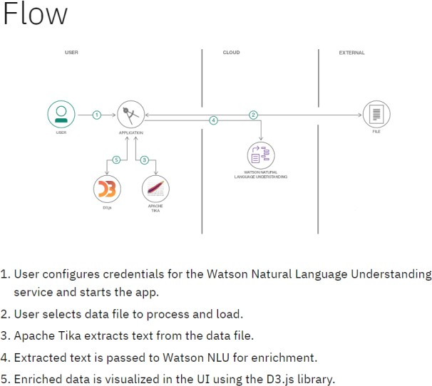

**UserStories**

Usethebelowtemplatetolistalltheuserstoriesfortheproduct.

|  |  |  |  |  |  |  |
| --- | --- | --- | --- | --- | --- | --- |
| **UserType** | **Functional Requireme nt (Epic)** | **User Story Numbe r** | **UserStory/Task** | **Acceptance criteria** | **Priority** | **Release** |
| Policymaker | Data Analysis &Visualizatio n | USN-1 | AsaPolicymaker,Iwanttoview a world map showing economic freedom scores by country, so thatIcanquicklyidentifyregions with high or low economic  prosperityandpotentialpolicy impact areas. | Themapcorrectly displayseconomic freedom scores, and I can identify regions visually. | High | Sprint-1 |
| Economic Researcher | Data Analysis &Visualizatio n | USN-2 | As an Economic Researcher, I want to filter economic data by specific years and countries, so that I can conduct in-depth analysisonhistoricaltrendsand compare performance across  differentnations. | I can apply filters for years and countries,andthe data displayed updates accordingly. | High | Sprint-1 |
| Investor | Data Analysis &Visualizatio n | USN-3 | AsanInvestor,Iwanttoseethe top 40 and least ranked countries based on their economic index, so that I can identify potential investment opportunities or risks in various  markets. | Thelistoftopand least ranked countries is accurate and easilyaccessible. | High | Sprint-1 |
| User | Data Ingestion &Managemen t | USN-4 | AsaUser,Iwanttouploadnew economic datasets (e.g., CSV, Excel),sothatIcanincorporate the latest information into the  analysisandupdatetheindex. | Icansuccessfully uploadadataset, and its data is visible in the  system. | Medium | Sprint-2 |
| Economic Researcher | Data Analysis &Visualizatio n | USN-5 | As an Economic Researcher, I want to view correlations betweeneconomicfreedomand indicators like unemployment rate and GDP growth, so that I canunderstandthemultifaceted  impactsofeconomicpolicies. | The system generatesareport with selected criteria, and I can download it in my desired format  (e.g.,PDF). | High | Sprint-2 |
| User | Reporting&Export | USN-6 | As a User, I want to export visualizations (e.g., charts, maps)asimagefiles,sothatI can easily include them in presentations or reports. | I can export displayed visualizationsas imagefiles(e.g., PNG, JPEG). | Medium | Sprint-1 |
| Administrator | User Managemen t &  Authorizatio n | USN-7 | As an Administrator, I want to manage user accounts and roles,sothatIcanaccesslevels  tosensitivedataand functionalities. | I can add, edit, and removeusers,andassign. | High | Sprint-1 |